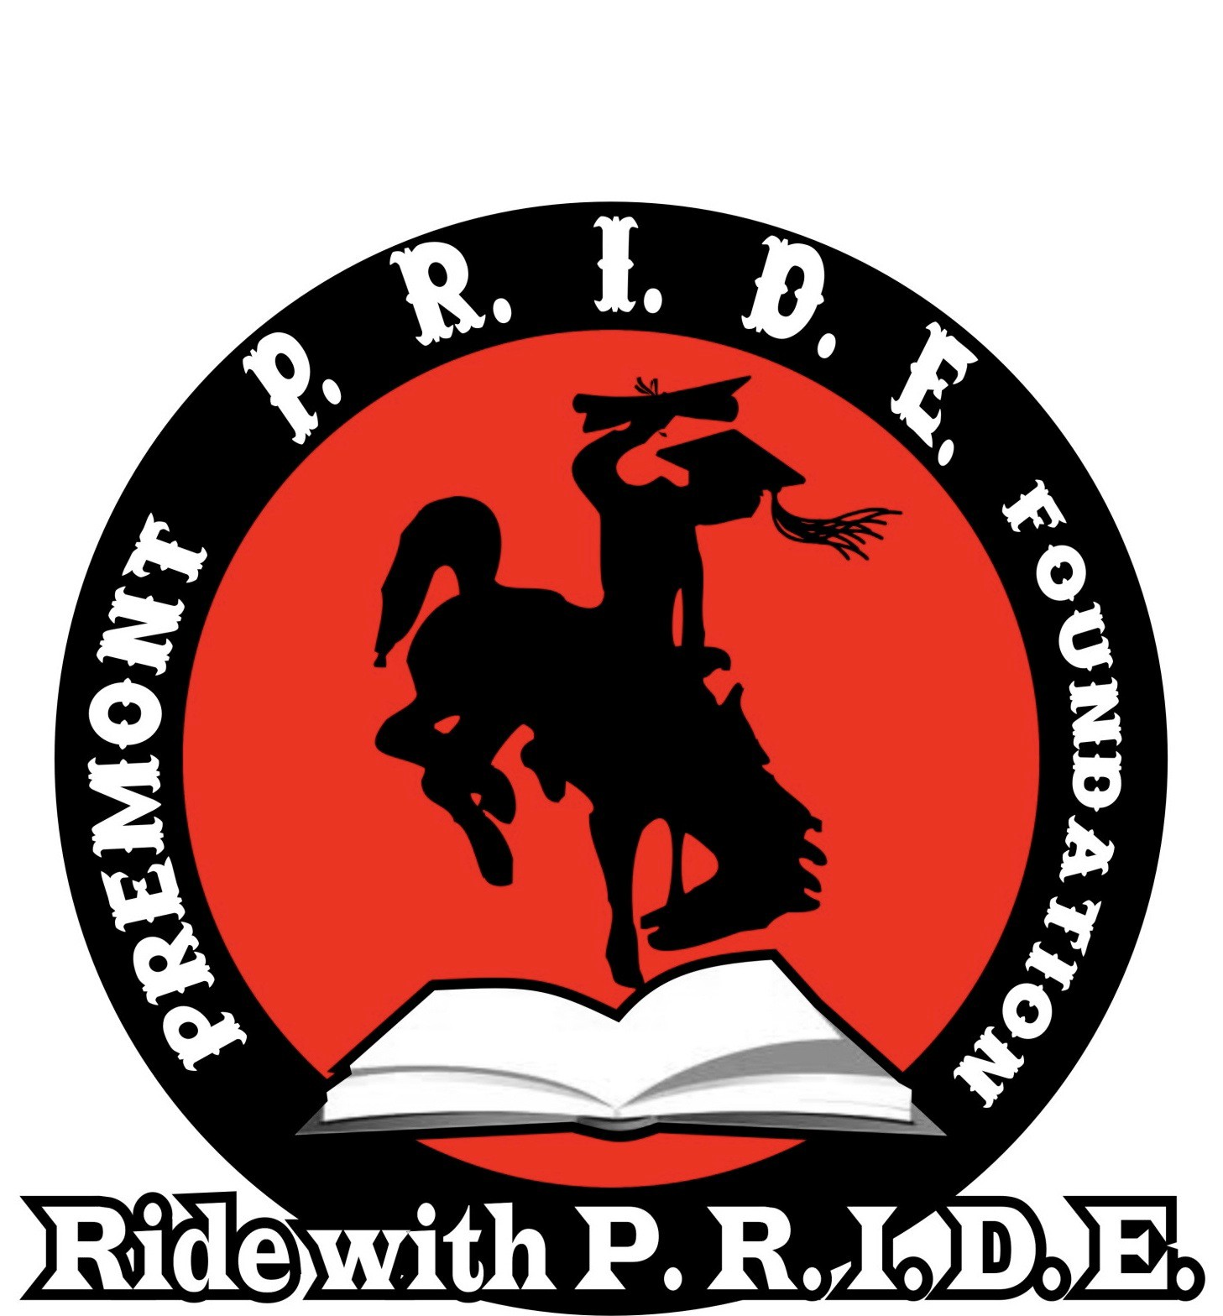
Dear Friend,
The Premont P.R.I.D.E. Foundation (Premont Residents Involved in Dynamic Education) is a Texas non-profit organization. Our Foundation is dedicated to making a difference in the community of Premont by inspiring our youth. On June 21-22, 2019, we will be hosting our 8th Annual “Summer in the Park ” which serves as our annual fundraising event. We are actively soliciting donations to help defray the costs associated with this great community event as well as to help provide our Foundation with much needed funds to assist us in achieving our mission as a charitable foundation.
Over the last few years through generous donors like you, P.R.I.D.E. has been able to contribute well over $100,000 to the youth of our community by providing back to school supplies, helping school organizations, little league, youth sports and activities like 4-H. We have provided scholarships to 23 students at Premont ISD and gifted each child in the community with a book at Christmas. To learn more about P.R.I.D.E., visit our website and “Like” us on Facebook.
Should you consider donating to our Foundation, we will list your donation on our website (www.premontpride.org) as well as on our Facebook Page (www.facebook.com/premontpride). In addition to this, any donations of $250 or more will be advertised on our “Summer in the
Park” T-shirts and on signage at the event.
On-line donations are possible on our web page www.premontpride.org via PayPal or if you prefer you can mail a check made payable to the Premont P.R.I.D.E. Foundation P.O. Box 401, Premont, Texas 78375-0401.
We sincerely thank you for considering this great opportunity to support our Foundation and the youth of the community of Premont, Texas. Should you have any questions about our Foundation, we encourage you to contact us at the numbers listed below.
Sincerely,

Donita Powell, President

Premont P.R.I.D.E. Foundation Board Members:
Donita Powell, President
361-522-3004
Diana Cantu, Vice-President
361-227-8777
Debra Lopez , Treasurer
361-562-5334

The Premont P.R.I.D.E. Foundation is a Texas non-­‐profit corporation. IRC Section 501c(3) charitable status approved. Gifts are tax deductible to the extent allowed by law.

